High Level Document

Content

1. System architecture………………………………………………………….. 1
2. System Requirement…………………………………………………………. 2
3. Modules & Features …………………………………………………………….3

**System Architecture**

A system architecture is the conceptual model that defines the structure, behavior , and more views of a system. An architecture description is a formal description and representation of a system, organized in a way that supports reasoning about the structures and behaviors of the system**.**

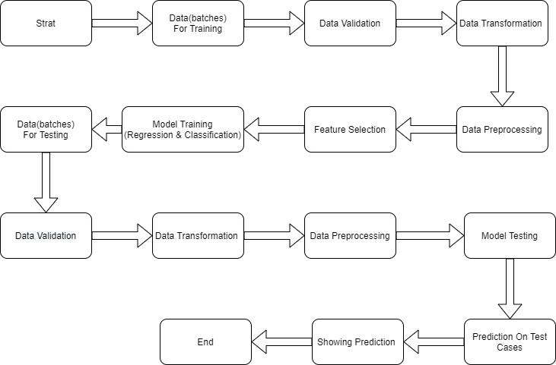

**System Requirement**

Software Requirements:

OS: Linux or Windows 7 or higher version

Language: Python

Hardware Requirement:

Ram : 2GB or more

Processor: Any Intel Processor

Hard Disk : 6GB and more

Platform : Jupyter Lab

**Modules & Feature**

Module:

Main module contains all the code of this project

Feature:

Cycle ( No of last Flight )

SensorMeasure2,

SensorMeasure3,

SensorMeasure4,

SensorMeasure7,

SensorMeasure8,

SensorMeasure9,

SensorMeasure11,

SensorMeasure12,

SensorMeasure13,

SensorMeasure14,

SensorMeasure15,

SensorMeasure17,

SensorMeasure20,

SensorMeasure21

Sensor Measures are the reading of the engine by various scales.